Significant Partnership Deal Signed between
EFACEC and HIMA
COTS control system from collaborative design as a central component of major level crossing modernization project in Sweden
(Brühl, October 28, 2019)
HIMA Paul Hildebrandt GmbH, the world's leading independent provider of smart safety solutions, has entered into an extensive partnership with railway specialist EFACEC. The Portuguese company recently won a large tender in the European level crossing systems market. EFACEC has been contracted by Trafikverket (Swedish railway and road infrastructure operator) to develop, certify and supply the latest generation of automatic level crossing safety systems. HIMA's compact and standardized commercial off-the-shelf (COTS) controllers are the cornerstone for safety of the new level crossing solution.
Sweden had already submitted a plan for the digitalization of rail in 2017, and now its rail infrastructure owner is relying on COTS solutions for the modernization of level crossings. For EFACEC, this major project in Sweden involves the modernization of a significant part of the Swedish level crossings over a period that can extend over the next 25 years and include more than a thousand units. Answering to Trafikverket’s specific requirements, EFACEC’s XSafe level crossing control system will be used - XSafe is the latest version of EFACEC's automatic level crossing control system, based on HIMA's proven COTS technology, and for this particular project the HIMatrix F30 COTS controllers will be used.
For more than a decade, EFACEC has been working with HIMA as safety supplier to EFACEC’s signaling and level crossing solutions. Recently, besides the specific contract for the level crossing project in Sweden, another contract was signed between EFACEC and HIMA concerning an overall partnership covering technological cooperation, training for EFACEC employees, detailed documentation and the necessary software tools.
"For EFACEC, this major order to modernize level crossings in Sweden is an important milestone," said Pedro Pinto, Manager of EFACEC’s Transportation Business Unit. "With the innovative concept of XSafe – using COTS technology – we were able to prevail against strong European competitors. At the same time, we have continued our successful partnership with HIMA. Our aim is to further expand our position in Scandinavia as a supplier of safety-critical systems for rail transport."
Sedat Sezgün, Group Vice President Business Segment Rail at HIMA, commented: "This new partnership with EFACEC in such a major project is another important step for us as a provider of COTS solutions. COTS is already widely used as a forward-looking and competitive solution in European rail networks and, in addition to SIL4 certification in accordance with CENELEC, offers many advantages in terms of standardization and flexibility as well as great cost reduction potential".
The powerful XSafe controller is based on the SIL4-certified HIMatrix series from HIMA. Its decentralized design with IP-based communication to individual modules has proven to be outstanding for this type of application, especially with regard to interfacing with other railway systems. This enables significant cost reductions, among other aspects in optimized cabling. Thanks to the modularity and flexibility of the HIMatrix platform, XSafe offers a highly configurable solution suitable for almost any type of level crossing. EFACEC and HIMA have, for example, already successfully deployed XSafe level crossing systems in Portuguese and Polish rail infrastructure, and a similar architecture based on HIMatrix platform is also used in EFACEC’s AEGIS Interlocking system, already in service in Oporto Metro (Portugal), Dublin Light Rail (Ireland) and being installed at Odense Light Rail (Denmark).

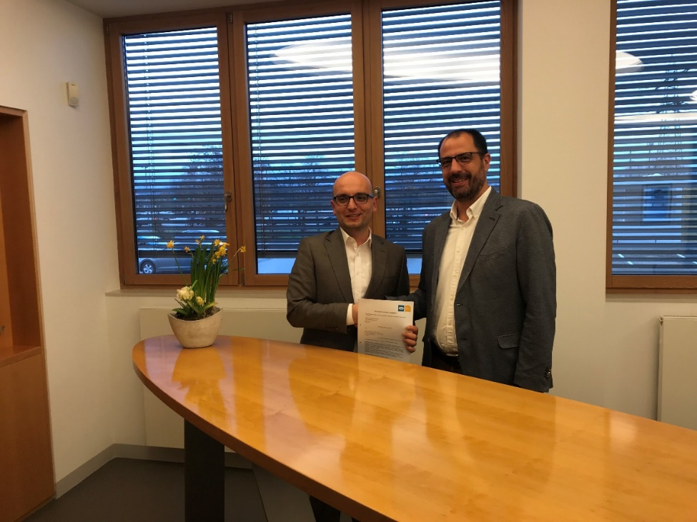
Image 1: (left to right) Sedat Sezgün, Group Vice President Business Segment Rail at HIMA, and Pedro Pinto, Manager of EFACEC’s Transportation Business Unit, signed the partnership deal.
Image © HIMA Paul Hildebrandt GmbH
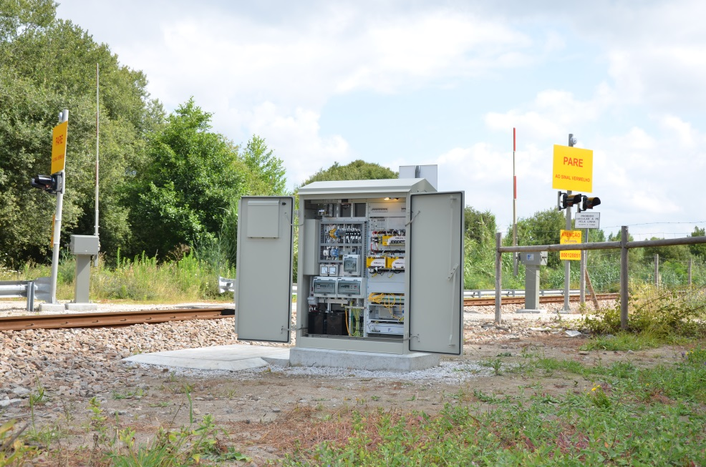
Image 2: Automatic level crossings systems based on COTS technology will be more frequently seen in Sweden in the future. Our photo shows a level crossing safety system at Linha do Minho in Portugal, developed and installed by EFACEC and HIMA.
Image © EFACEC
About HIMA
The HIMA Group is the world's leading independent provider of smart safety solutions for industrial applications. With more than 35,000 installed TÜV-certified safety systems worldwide, HIMA qualifies as the technology leader in this sector. Its expert engineers develop customized solutions that help increase safety, cyber security and profitability of plants and factories in the digital age. For over 45 years, HIMA has been a trusted partner to the world's largest oil, gas, chemical, and energy-producing companies. These rely on HIMA solutions, services and consultancy for uninterrupted plant operation and protection of assets, people and the environment. HIMA’s offering includes smart safety solutions that help increase safety and uptime by turning data into business-relevant information. HIMA also provides comprehensive solutions for the efficient control and monitoring of turbomachinery (TMC), burners and boilers (BMC) and pipelines (PMC). In the global rail industry, HIMA’s CENELEC-certified SIL4 COTS safety controllers are leading the way to increased safety, security and profitability. Founded in 1908, the family-owned company operates from over 50 locations worldwide with its headquarters in Bruehl, Germany. With a workforce of approximately 800 employees, HIMA generated a turnover of approximately €123 million in 2017. For more information, please visit: www.hima.com

Press contact HIMA Headquarters

HIMA Paul Hildebrandt GmbH
Daniel Plaga
Group Manager Global PR

Albert-Bassermann-Straße 28
68782 Bruehl
Phone: +49 6202 / 709-405
Cell : +49 172 / 3224 944
E-Mail: d.plaga@hima.com

Agency press contact / Please send voucher copies to

Mark Herten, Publitek  Post Office Box 12 55, 21232 Buchholz  Phone: +49 (0)4181 968 09820  Mobile: +49 (0)1520 748 3901  E-Mail: mark.herten@publitek.com | Carsten Otte, Publitek  Phone: +49 (0)4181 9680 09880  Mobile: +49 (0)1520 915 8629  E-Mail: carsten.otte@publitek.com

